Project 7
CS 557 - Computer Graphics Shaders
Name: Tianle Yuan (933-946-576)
Project Number: 7
Project Name: Geometry Shaders for Quantizing 3D Geometry: The Lego™ Project
Video Link: https://media.oregonstate.edu/media/t/1_k8va9ec8
Email: yuant@oregonstate.edu
Time: March 4, 2020

Screen shot:

Firstly, let us show the effects after change uLevel (when uQuantize = 13.12):

uLevel = 0:
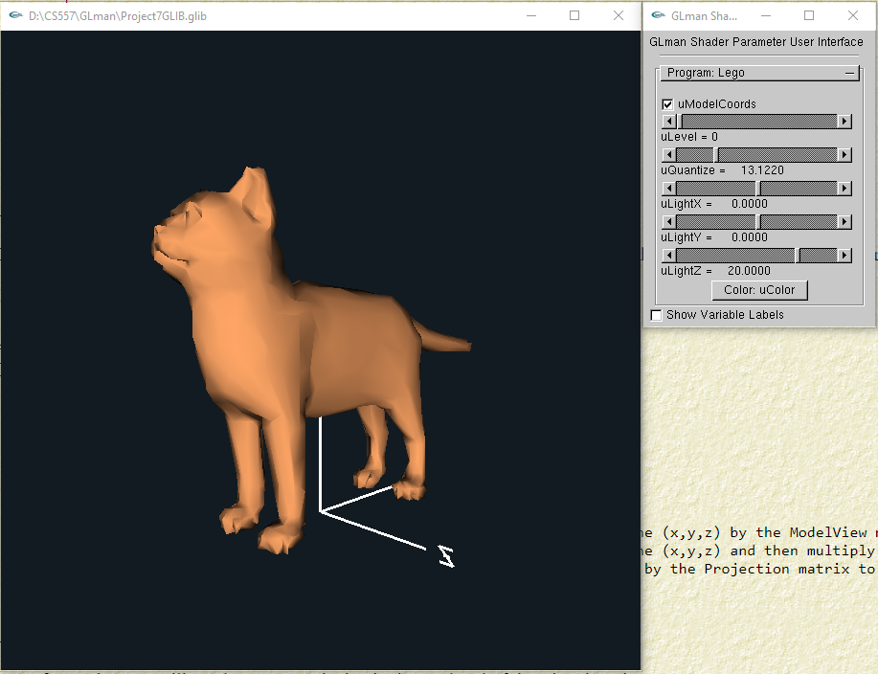
uLevel = 1:
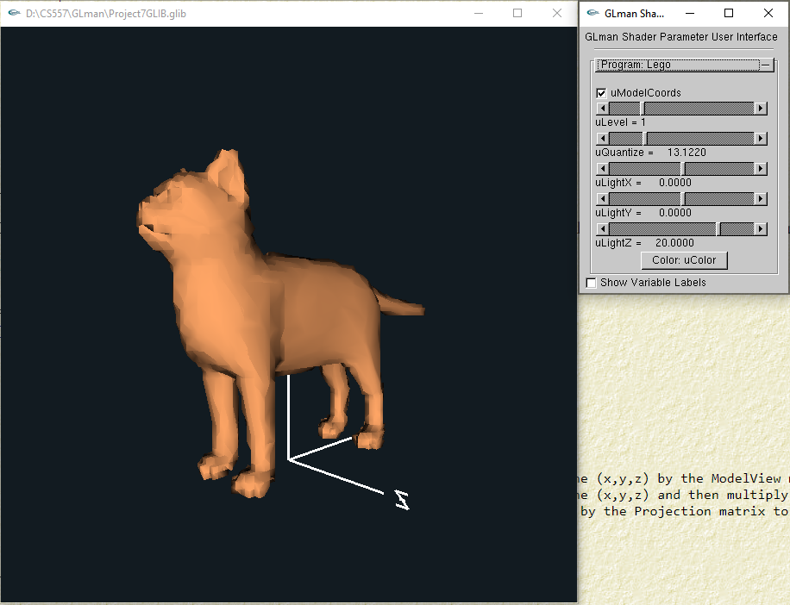
uLevel = 2:
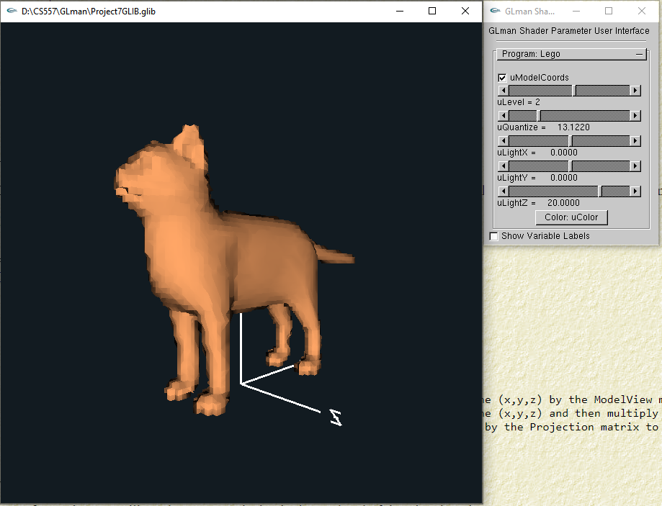

uLevel = 3:
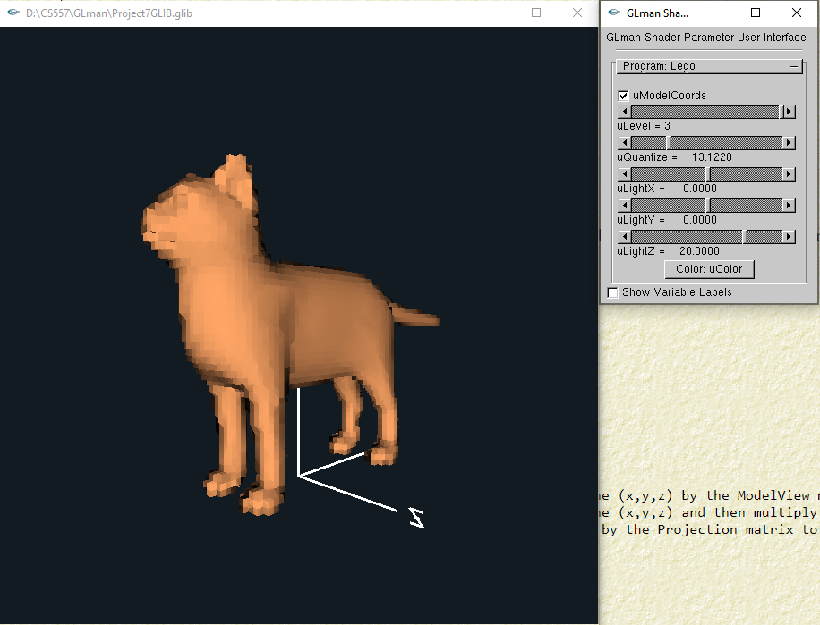

Secondly, let us show the effects after change uQuantize (when uLevel = 3):

uQuantize is small:
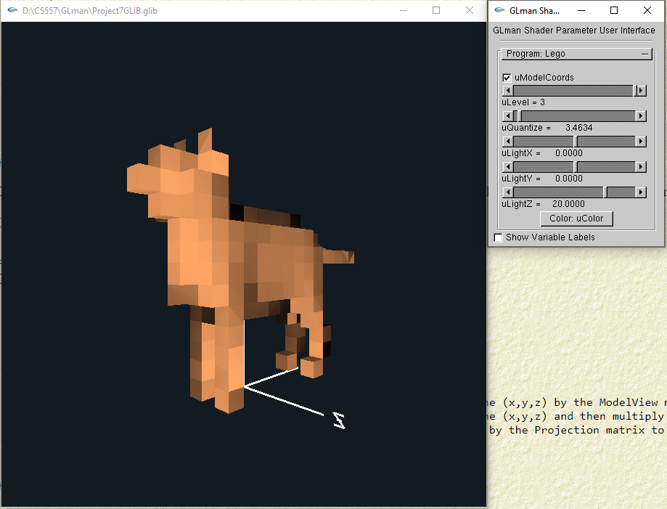
uQuantize is in a middle:
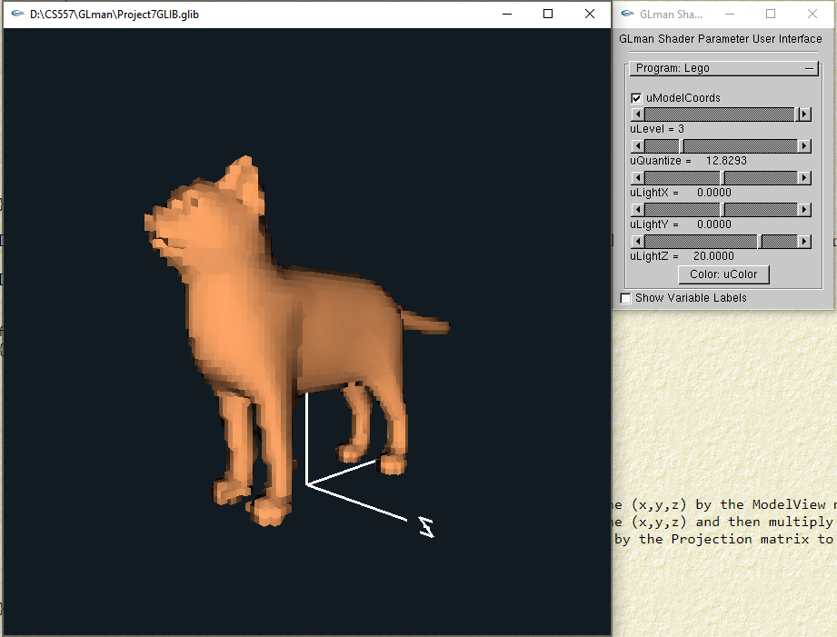
uQuantize is large:
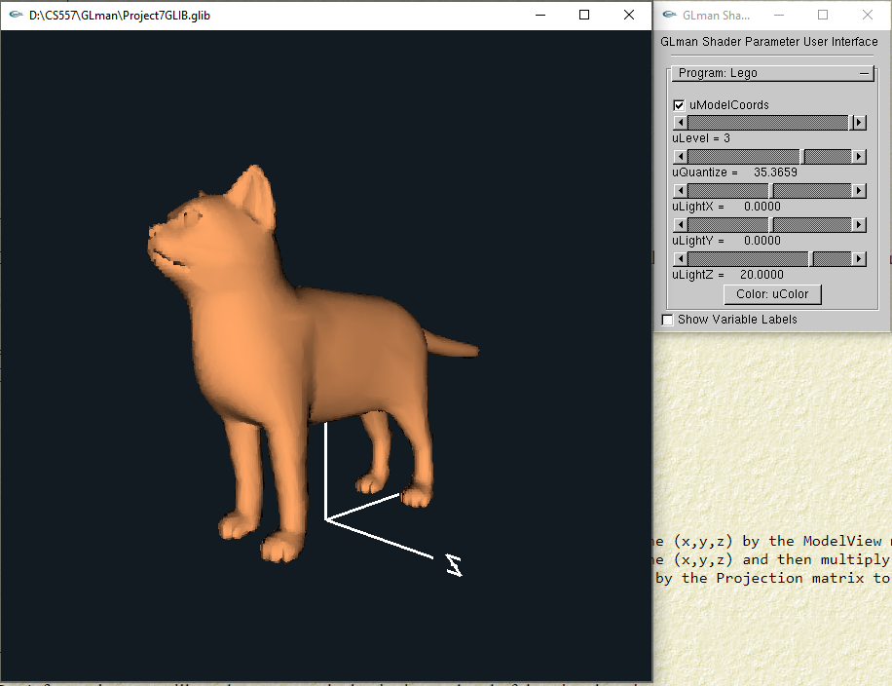

Thirdly, let us show the effects after change uModelCoords (when uLevel = 3, uQuantize= 4.9):
When uModelCoords is true:
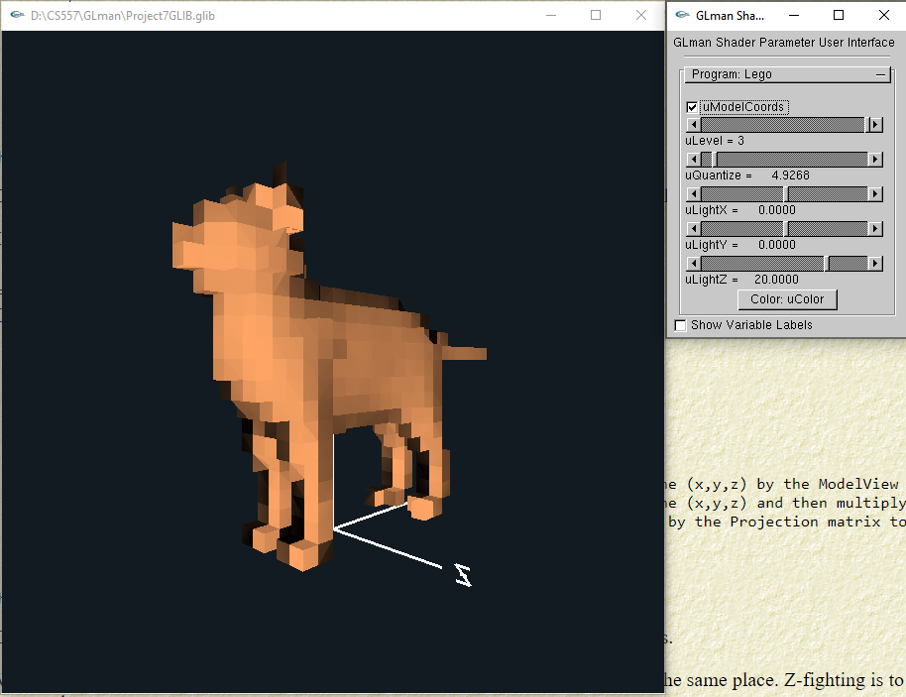
When uModelCoords is false:
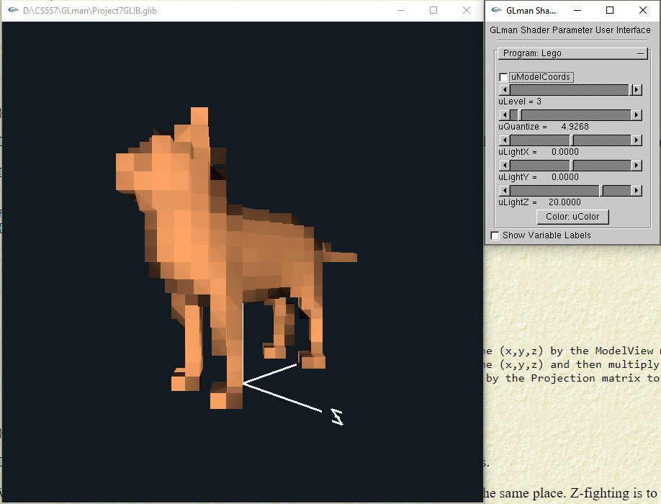

Finally, let us show the effects after change uLightX, uLightY, uLightZ (when uLevel = 3, uQuantize= 4.9, uModelCoords = true):
When uLightX = -40.0:
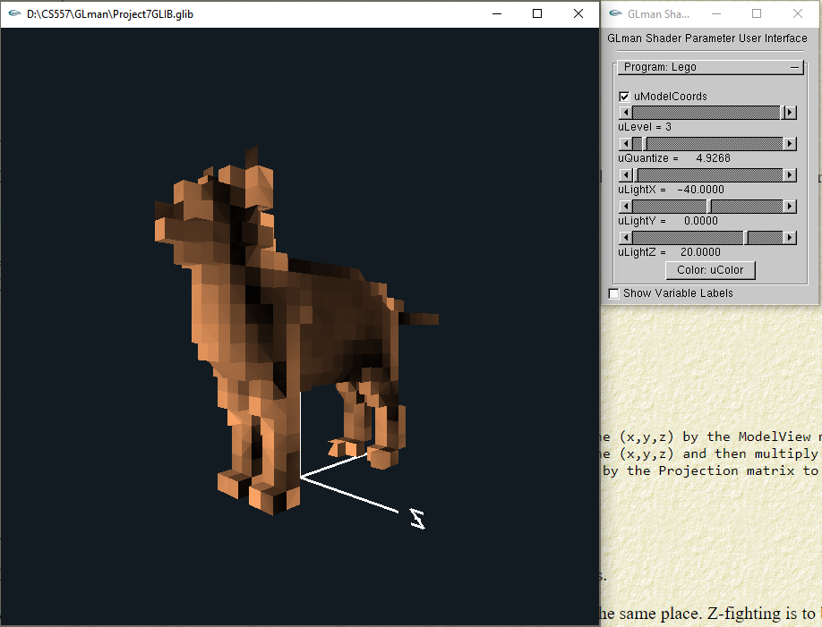
When uLightX = 40.0:
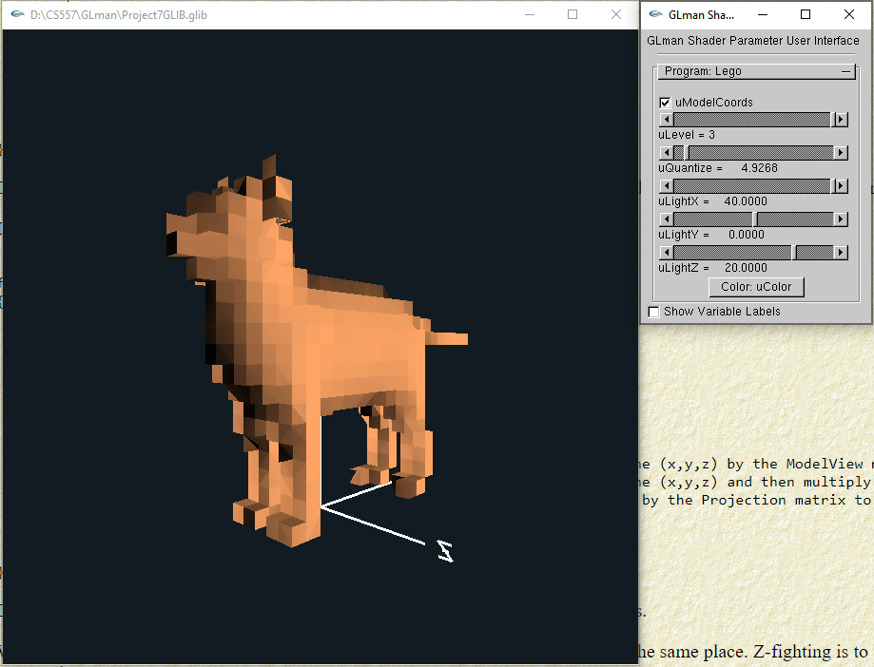

When uLightY = -40.00:
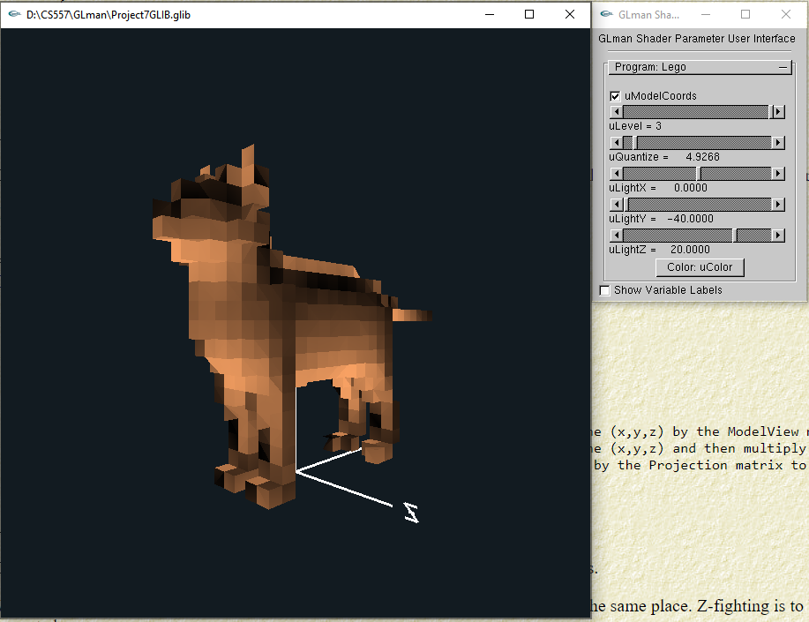

When uLightY = 40.00:
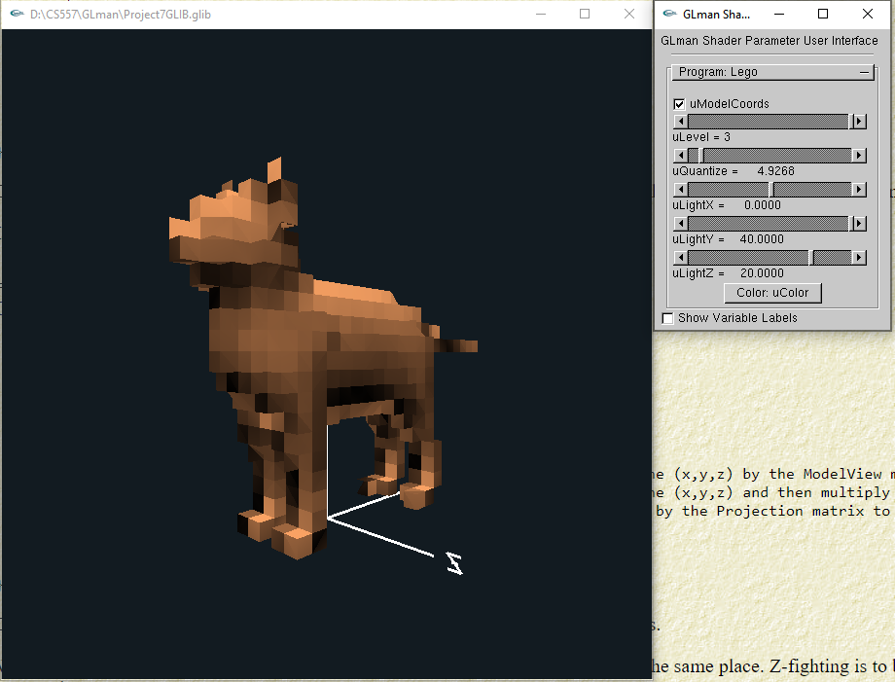

When uLightZ = 40.00:
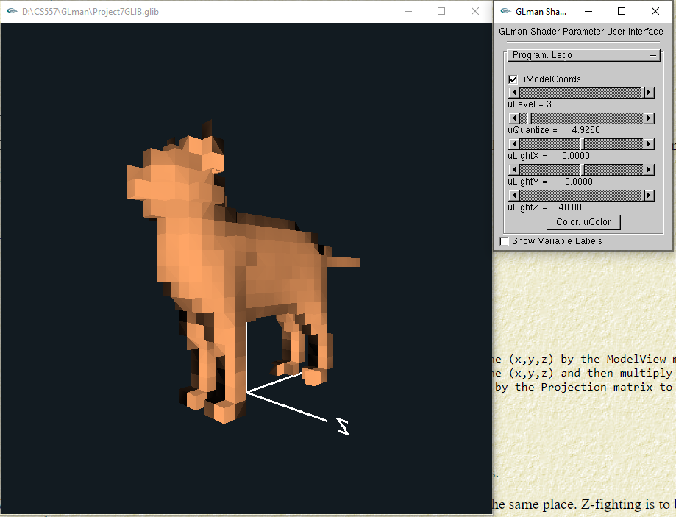

When uLightZ = -3.90:
